12th International Conference on Industrial Engineering and Industrial Management
XXII Congreso de Ingeniería de Organización
Girona, Spain, July 12-13, 2018

Logistics Management Optimization for a Container Port Terminal (in English; use the “Title” style)

THE MAXIMUM NUMBER OF PAGES IS EIGHT (including references). The paper should contain the following sections.
Abstract The abstract should be a single paragraph in English. The abstract should be self-contained and cover the background/motivation, research questions or application, and the main results related to the proposed conference presentation. Mathematical notation should be avoided as far as possible. (Use the “Abstract” style.)
Keywords: Up to 5 (for papers written in English);
1 Section Heading (“H1” style)
Please note that the first line of text that follows a heading is not indented (“p1a” style).
The first lines of all subsequent paragraphs are (“Normal” style).
2 Section Heading
Please use the “Equation” style for equations and positioned correctly using one tab space before and one after, as below.
a + b = c (1.1)
2.1 Subsection Heading (“H2” style)
The main words in all headings (even run-in headings) begin with a capital letter. Articles, conjunctions and prepositions are the only words which should begin with a lower case letter.
2.1.1 Subsubsection Heading (“H3” style)
Instead of simply listing headings of different levels we recommend that every heading is followed by at least a short passage of text.
- Numbered lists should use the “Numbered Item Text” style.
- Numbered lists should use the “Numbered Item Text” style.
- Numbered lists should use the “Numbered Item Text” style.
Lists should either use the “Numbered Item Text” or “Bullet Item Text” styles.
- Unnumbered lists should use the “Bullet Item Text” style.
- Unnumbered lists should use the “Bullet Item Text” style.
- Subitems in a list should use the “Subitem Text” style.
- Subitems in a list should use the “Subitem Text” style.
- Unnumbered lists should use the “Bullet Item Text” style.
Unnumbered Heading (“H4” style)
Please ensure that where the built-in spacing of two adjacent paragraph styles spacing is combined the space built-in to the inferior style is manually removed. In the above example, I have removed the 6 pt space which automatically follows the “Bullet Item Text” style, in favour of the 18 pt space which automatically precedes the “H5 (heading5)” style.
Unnumbered Heading, Second Option (“H5” style)
Please do not leave blank lines in the text, even when including block quotes:
Please do not use quotation marks when including block quotes. Simply use the “Quotation” style – it will automatically produce preferred layout.
Please do not leave large gaps at the bottom of a page. If a figure or table will not fit on the space left on a page, please reposition the figure so that it appears at a more convenient place in the text.
After insert a figure, select it and apply thestyle “Figure”.Then, on the Format tab, choose “In line with text”:

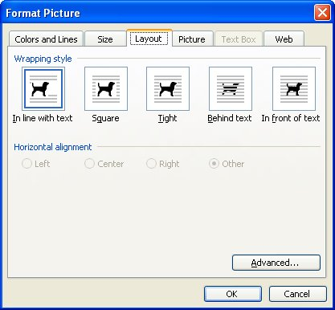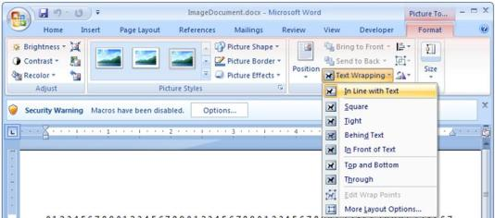
Fig. 1 Please use the “Figure Legend” style for figure legends. Note that “Fig.” and the figure number are in bold, while the rest of the legend is not. Figure legends appear below figures. There are no full stops after the figure number or the legend itself
Only the first word (as well as any proper nouns or abbreviations) in table and figure titles should begin with a capital letter.
Table 1Please use the “Table Title” style for figure legends. Note that “Table” and the table number are in bold, while the rest of the legend is not. Table legends appear above tables. There are no full stops after the table number or the legend itself
Heading | Heading | Heading | Heading
Item¹ | Item | Item | Item
Item | Item | Item | Item
Text in tables should use the “Table Text” style” | Text in tables should use the “Table Text” style” | Text in tables should use the “Table Text” style” | Text in tables should use the “Table Text” style”
¹Please use the “Table Footnote” style for table footnotes.
Tables can run over more than one page. If they do so in your book, please ensure that the table number and “(continued)” appear at the top of each new page on which the table continues. For example: Table 1 (continued).
If you have a particularly wide table, please do not change the orientation of the page from portrait to landscape. Instead, create the table with its top row parallel with the left margin and its bottom row parallel with the right margin of the page. The legend should run parallel to the top row.
If you wish to highlight text using a box, please use the “Important Text” style to ensure it is formatted correctly. If you wish to emphasise certain words or phrases in the text, please use italics, not bold or underlining.
Options
Click the angle
To work with styles, we recommended using “The Styles Ribbon menu extended”, and in options choose view only styles “In current Document” or better “In use”:
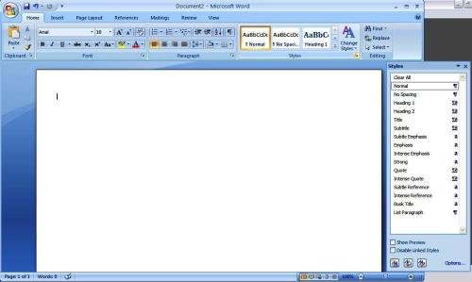
Fig. 2 Please use the “Figure Legend” style for figure legends. Note that “Fig.” and the figure number are in bold, while the rest of the legend is not. Figure legends appear below figures. There are no full stops after the figure number or the legend itself

3 References
Please use Harvard style with a list of references sorted alphabetically as it is presented below. Please ensure the Harvard format is used (author, year) throughout the paper. Use the “References” style.

Dod J (1999) Effective Substances. In: The dictionary of substances and their effects. Royal Society of Chemistry. Available via DIALOG. http://www.rsc.org/dose/title of subordinate document. Cited 15 Jan 1999
Slifka MK, Whitton JL (2000) Clinical implications of dysregulated cytokine production. J Mol Med, doi: 10.1007/s001090000086
Smith J, Jones M Jr, Houghton L et al (1999) Future of health insurance. N Engl J Med 965:325–329
South J, Blass B (2001) The future of modern genomics. Blackwell, London

To insert a footnote simply choose the “Footnote Text” style.

